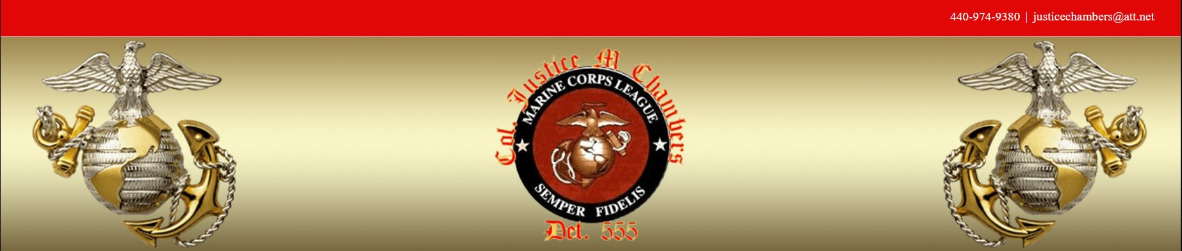
248th USMC
Birthday Ball
Saturday November 11th 2023
Gunny’s Hall 8720 Twinbrook Dr.
Mentor, Ohio 44060
5-7 PM appetizers and open bar
6 PM Color Guard Presentation
Pledge of Allegiance
Commandants Message
Guest Speaker
Cake Cutting Ceremony
Dinner Follows
Steak, Chicken, or Salmon
Music and Dancing till 11PM

