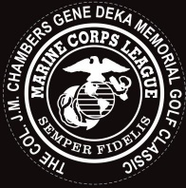 34th Annual Col. J M Chambers
Gene Deka/Joe Brooks memorial golf classic
Blackbrook GC Mentor, Ohio June 15th 9am shotgun
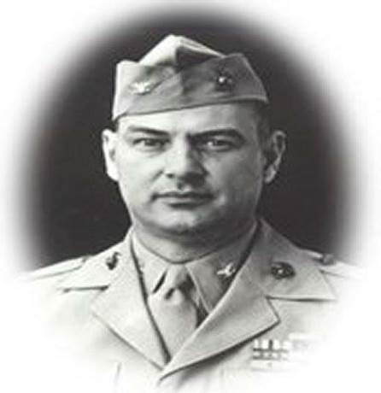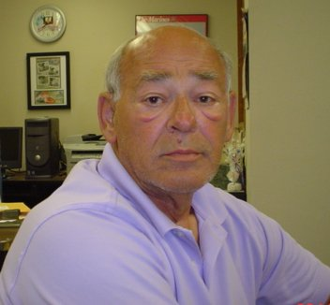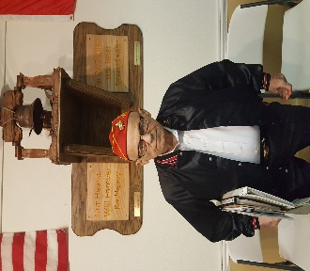
Dear friends
Col. J. M. Chambers Marine Corps Detachment 555 is a non-profit military organization, that prides itself in giving back to the community. We have served our country and now serve our Corps and community. We sponsor Toys for Tots, scholarships to Lakeland Community College, Youth Fitness, Active duty Marines, Young Marines of Lake County, Veterans and Purple Heart Homes.
We cannot do this without your help. This golf outing is our biggest fundraiser. Your entry fee of $100 per golfer, Hole Sponsorship of $100 Bronze, $200 Silver, $500 + Gold Prize Donation, makes it possible for us to support all these great people. The golf outing is a 18 hole shotgun start and includes golf, cart, lunch, dinner, Golf Shirt and prizes. Our pride and joy is The Lake County Marine Veteran Honor Guard which is made up of our members. The Guard helps with all veteran funerals, and they march/post colors in many community events. They are involved in over 300 events a year.
In return for your Hole Sponsorship or Prize Donation we will link your business on our website for one year. https://colchambers.org/supporters
Col. Chambers Det. 555 8720 twinbrook dr. mentor, ohio 44066 440-974-9380
https://colchambers.org/GolfOuting
For Sponsors help call Frank Gron 440-223-8257
All checks made payable to Gunnys Hall Foundation

