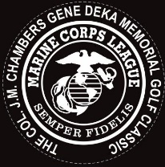 The 34th Gunnys Hall/ Col. Chambers
Marine Corps League Golf Classic
Saturday June 15th 9 am shotgun
Black Brook GC Mentor, Ohio
18 hole scramble $100@
Trophies, prizes, lunch & dinner, skin game is extra & Chinese raffle prizes
A chance to win a car with a Hole in One
Send check or cash and registration or hole sponsorship
Make checks payable to : Gunnys Hall Foundation
Your donation is tax deductible
Mail to: 8720 Twinbrook Dr. Mentor, Ohio 44066

